**Day 6 Lab Assignments**

**Please do these assignments:**

1. **find out the rockbands.json file to make a page with 2 dropdown lists, the 1st one is filled with the band and the 2nd one is filled with the artist after selecting a band from its dropdown list. Once the user**



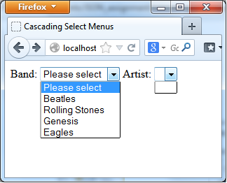





**2- Cookies Make your own .js library to create, display and delete cookies, then use it in creating the required cookies to display a greeting message to your visitor with displaying an image as his profile pic referring to his gender, and inform him with his number of visits to the site. Display user name and number of visits with font color according to his choices. Replace the registration page with the profile page using location object**

**the library should have the following functions:**

• getCookie(cookieName):

o **Retrieves a cookie value based on a cookie name.**

• setCookie(cookieName,cookieValue[,expiryDate]):

o **Sets a cookie based on a cookie name, cookie value, and expiration date.**

• deleteCookie(cookieName):

o Deletes a cookie based on a cookie name.

• allCookieList():

o **returns a list of all stored cookies**

• hasCookie(cookieName):

o Check whether a cookie exists or not

**Note: Don’t use <form> tag**





**3-** use local storage to save user name and password in the prev. assignment, when user press login button, and retrieve them on page load and write them to the textboxes.

* 1. Can you use session storage in the previous assignment? Why?
  2. What’s the difference between local storage and session storage?
  3. Can you access local storage and session storage in another page than the page that created it (on the same site)?

4-In the previous Assignment, add “remember me” check box, and save user name and password only if the user checked this checkbox, and if the user didn’t check it, remove the saved user name and password from local storage if they saved before.

**<Script>document.write(“Thank YOU”) </Script>**